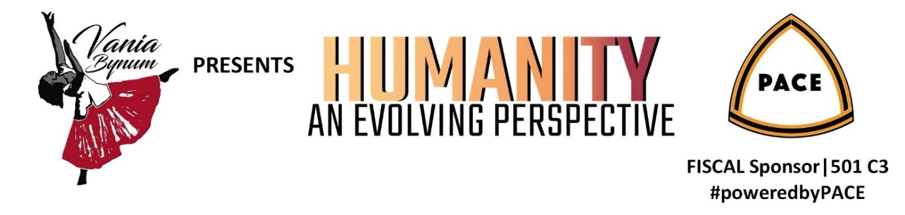

Fact Sheet

Event Date: | Saturday, December 18, 2021
Time | 4:00 PM Pacific Daylight Time
Venue | Online with Stream Yard
Description | VCBynum Arts and Education Fund Raising Event  Sponsoring Special Moments for kids and an Individual Artist in need
Audience | Professional, community-minded and philanthropic men and women from the business community.
Key Performers | Josephine Howell  Vania Bynum  Yvonne Matthews  DianaStarr Raynell
Proceeds Benefit | Special Moments for Kids  Local Performing Artists
Fundraising goal | $10,000
Grants & Awards | 2020 Jack Straw Artist Support Program  2020 smART ventures grant  2021 Philanthropy Northwest Grant
Fiscal Sponsor | En Pointe Starrs is a tax-exempt public charity under Section 501(c)(3) of the IRS Code (EIN 86-2462284)
For more information | Contact Vania Bynum  (425) 591-4685  vcb@vaniacbynum.com  www.weinspirehumanity.com

 | SPONSORHIP LEVELS
Benefits | Patrons of the Arts  $5,000 | Contemporary Champions  $2,000 | Hip Hop Warriors  $1,000 | Free Style Advocates  $500 | Heroes for Humanity  $100
Logo on event website
Logo appears throughout viewing
On Screen Video Message
Autographed Poster
Official Humanity: An Evolving Perspective T-shirt
Admittance to online event
Ad in event program booklet | Full page | Half page | 1/4 page | Bus Card
Ad posted on VC Bynum Arts and Education social media
Recognition by emcee during event
Name on event website

Questions? Please contact Vania Bynum at 425-591-4685 or email vcb@vaniacbynum.com
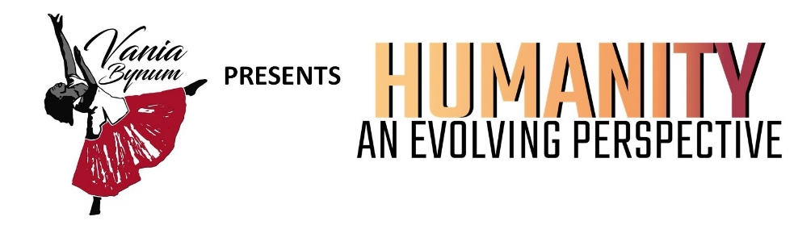

YES, I WANT TO BE A SPONSOR!

 | Patrons of the Arts |  | $5,000
 | Contemporary Champions |  | $2,000
 | Hip-Hop Warriors  Free Style Advocates |  | $1,000  $500
 | Heroes for Humanity |  | $100

Contact Name
Company
Address
City, State, Zip
Phone FAX
Email

Check Enclosed (payable to En Pointe StarrsKEF)

Charge to my…
MasterCard Visa Amount: $
Card #
3-digit security code on back of card: Exp. date
Name on card
Billing address
City, State, Zip
Signature

MAIL THIS COMPLETED FORM TO:
Vania C. Bynum
VCBynum Arts and Education
ATTENTION: HumanitY: An Evolving Perspective
14600 SE 8th Street | Bellevue, WA 98007
Phone: 425.591.4685
vcb@vaniacbynum.com | www.weinspirehumanity.org
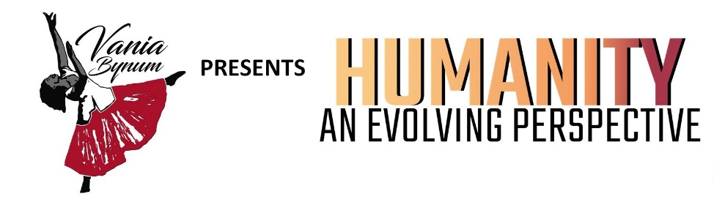

YES! I WANT TO PURCHASE AN AD IN THE PROGRAM BOOK!

Program Ad Sizes & Costs |  | COST
 | Full page ad (10” tall, 7.5” wide (portrait orientation) | $150.00
 | Half-page ad: 5” tall, 7.5” wide (landscape orientation) | $125.00
 | Quarter-page ad: 5” tall, 3.75” wide (portrait orientation) | $75.00
 | Business card ad: 2” tall, 3.5” wide (landscape orientation) | $ 50.00

Contact Name
Company
Address
City, State, Zip
Phone FAX
Email

Check Enclosed (payable to VC Bynum Arts and Education)

Charge to my…
MasterCard Visa Amount: $
Card #
3-digit security code on back of card: Exp. date
Name on card
Billing address
City, State, Zip
Signature

MAIL THIS COMPLETED FORM TO:
Vania C. Bynum
VCBYNUM ARTS AND EDUCATION
ATTENTION: HumanitY: An Evolving Perspective
14600 SE 8th Street | Bellevue, WA 98007
Phone: 425.591.4685
vcb@vaniacbynum.com | www.weinspirehumanity.com
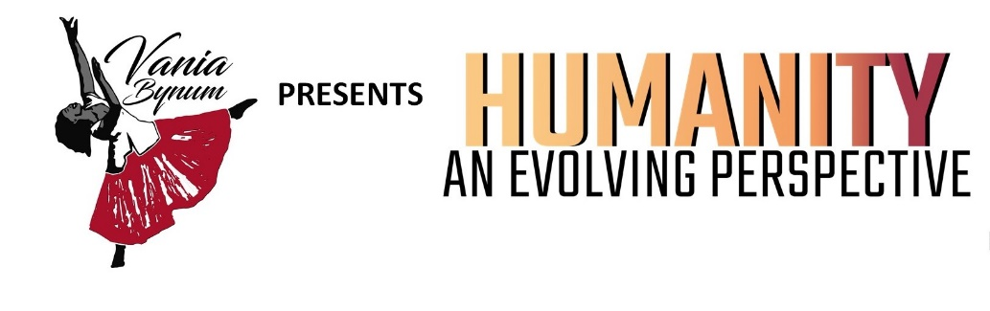

Graphic Guidelines for Ads

All sponsors receive an ad in the event program, as described below. Organizations may purchase just an ad if they prefer. In addition, all ads will be posted on VC Bynum Arts and Education social media pages. All camera-ready ads are due no later than 5pm on Friday, December 10, 2021.

Ad sizes are as follows:

- Full-page ad: 10” tall, 7.5” wide (portrait orientation).

Half-page ad: 5” tall, 7.5” wide (landscape orientation).

- Quarter-page ad: 5” tall, 3.75” wide (portrait orientation

- Business card ad: 2” tall, 3.5” wide (landscape orientation).

Ads can be full color or black and white and must be submitted electronically.

Please submit one PDF copy of your ad. Please do not include printer’s marks, crop marks, color bars, page information, etc. in your PDF.

Ads must be submitted via email to Twanda Hill, at twanda@twandahill.com. If you have any questions, please contact Twanda at (206) 248.6072.

If your organization does not have graphic design resources available, Twanda Hill can design an amazingly simple ad for you.

Thank you for supporting VCBynum Arts and Education!

